**Object Oriented Analysis and Design using Java**

**Self-Learning: MVC Framework**

**Lab Week 9**

|  |  |  |  |
| --- | --- | --- | --- |
| Vanshika Goel | PES1UG20CS484 | Section H | Roll No 40 |

1. **MVC Architecture Pattern**

The Model-View-Controller (MVC) pattern is an architectural design pattern that separates an application into three interconnected parts, namely Model, View, and Controller. Each of these components has its own unique responsibilities, as follows:

* Model: This represents the data and business logic of the application. The model is responsible for managing the application data and providing the services that manipulate this data.
* View: This represents the user interface of the application. The view is responsible for presenting the data to the user in a meaningful way and enabling user interaction with the application.
* Controller: This represents the application logic that mediates between the model and the view. The controller is responsible for receiving and processing user input, updating the model, and updating the view.

The MVC architecture pattern is widely used in web development, where the model represents the data stored in the database, the view represents the web page displayed to the user, and the controller represents the server-side code that handles user requests and updates the model and view accordingly.

1. **Advantages of MVC Pattern**

The MVC pattern has several advantages that make it a popular choice for software development, including:

* Separation of concerns: The MVC pattern separates the application logic into three distinct parts, which makes it easier to develop, test, and maintain the code.
* Reusability: The MVC pattern promotes reusability of code, as each component can be used in multiple applications or projects.
* Scalability: The MVC pattern allows for easy scalability of the application, as each component can be modified or replaced without affecting the others.
* Testability: The MVC pattern makes it easier to test the application, as each component can be tested independently.

1. **Features of Spring MVC Framework**

Spring MVC is a popular framework for building web applications based on the MVC architecture pattern. It provides several features that simplify the development of web applications, including:

* DispatcherServlet: This is the core of the Spring MVC framework, which receives requests and sends them to the appropriate controller for processing.
* Controllers: These are responsible for processing user requests and returning a response. Controllers are Java classes that handle user input and interact with the model and view.
* Model: This represents the application data and business logic. The model is typically implemented using JavaBeans or POJOs (Plain Old Java Objects).
* View: This represents the user interface of the application. Spring MVC supports several view technologies, including JSP (JavaServer Pages), Thymeleaf, and Velocity.
* HandlerMapping: This is responsible for mapping incoming requests to the appropriate controller.
* Interceptors: These are used to intercept requests and perform pre-processing or post-processing tasks.
* Form handling: Spring MVC provides several features for handling HTML forms, including form validation, data binding, and form submission.
* Integration with other Spring modules: Spring MVC can be easily integrated with other Spring modules, such as Spring Security, Spring Data, and Spring Boot.

In conclusion, the MVC architecture pattern is a widely used design pattern that promotes separation of concerns, code organization, and reusability. The Spring MVC framework provides several features that simplify the development of web applications based on the MVC architecture pattern. Spring MVC is a popular choice for building web applications due to its ease of use, scalability, and integration with other Spring modules.

1. **Problem definition with description of the chosen scenarios**

The application I chose is a Hospital Management System, specifically a Patient Management System.

The application I built using the Spring framework, Java as well HTML allows CRUD operations on a database on MySQL.

1. **Complete screenshot of the code**

Hms484Application.java

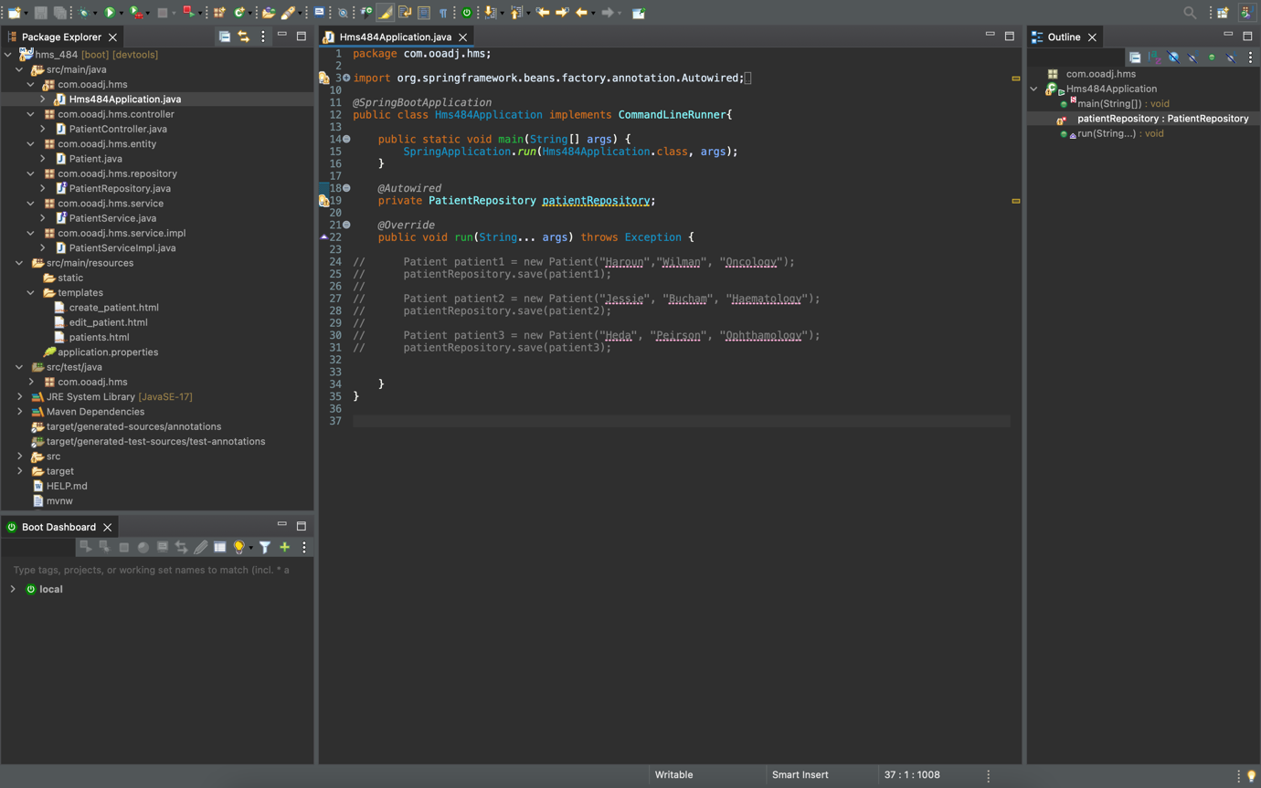

Patient.java

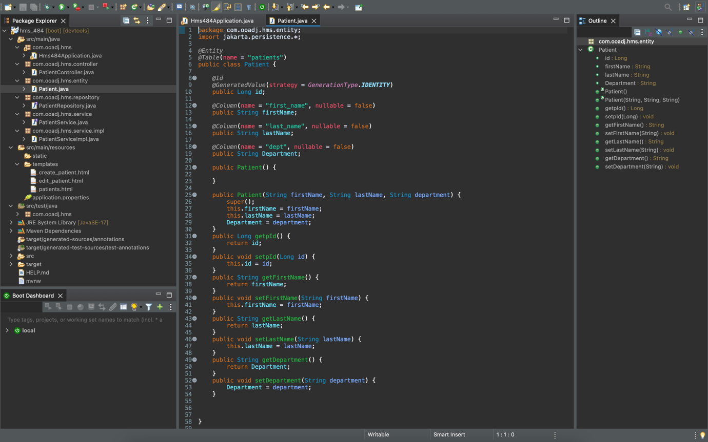

PatientRepository.java

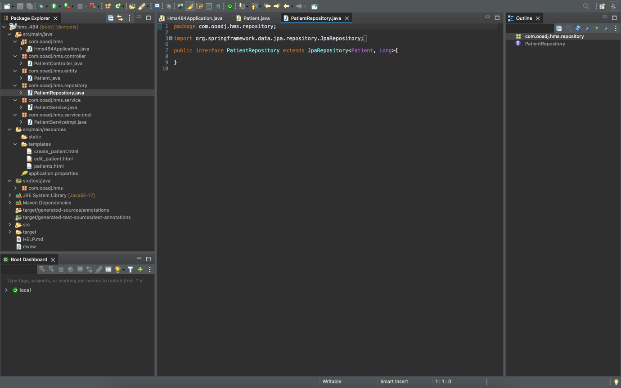

PatientController.java

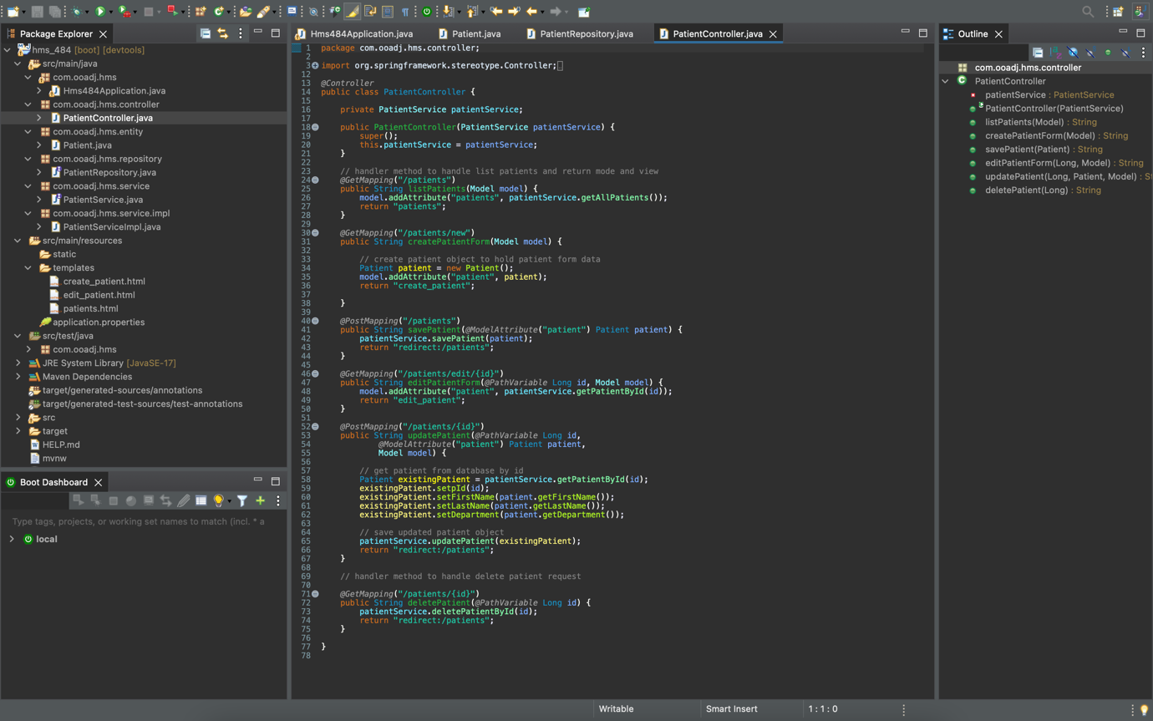

PatientService.java

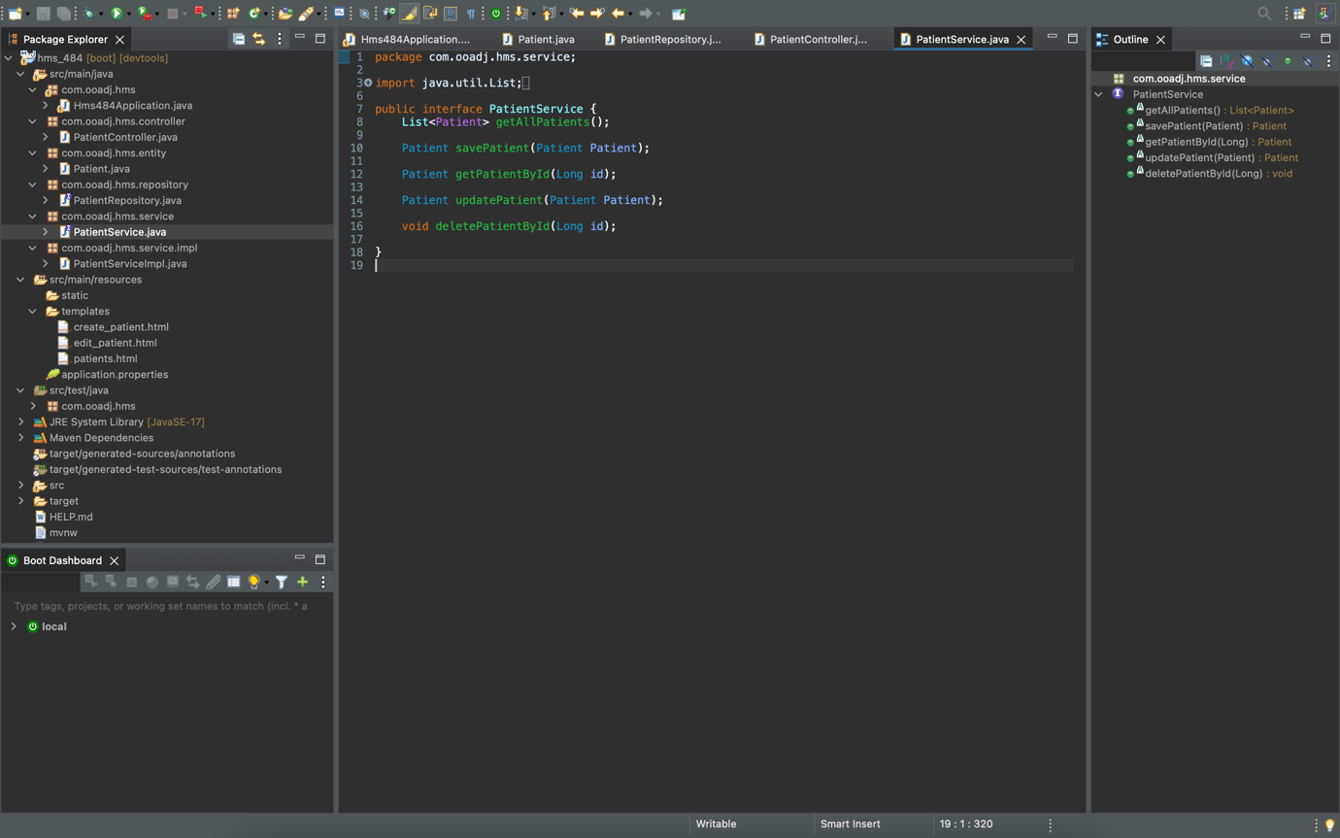

PatientServiceImpl.java

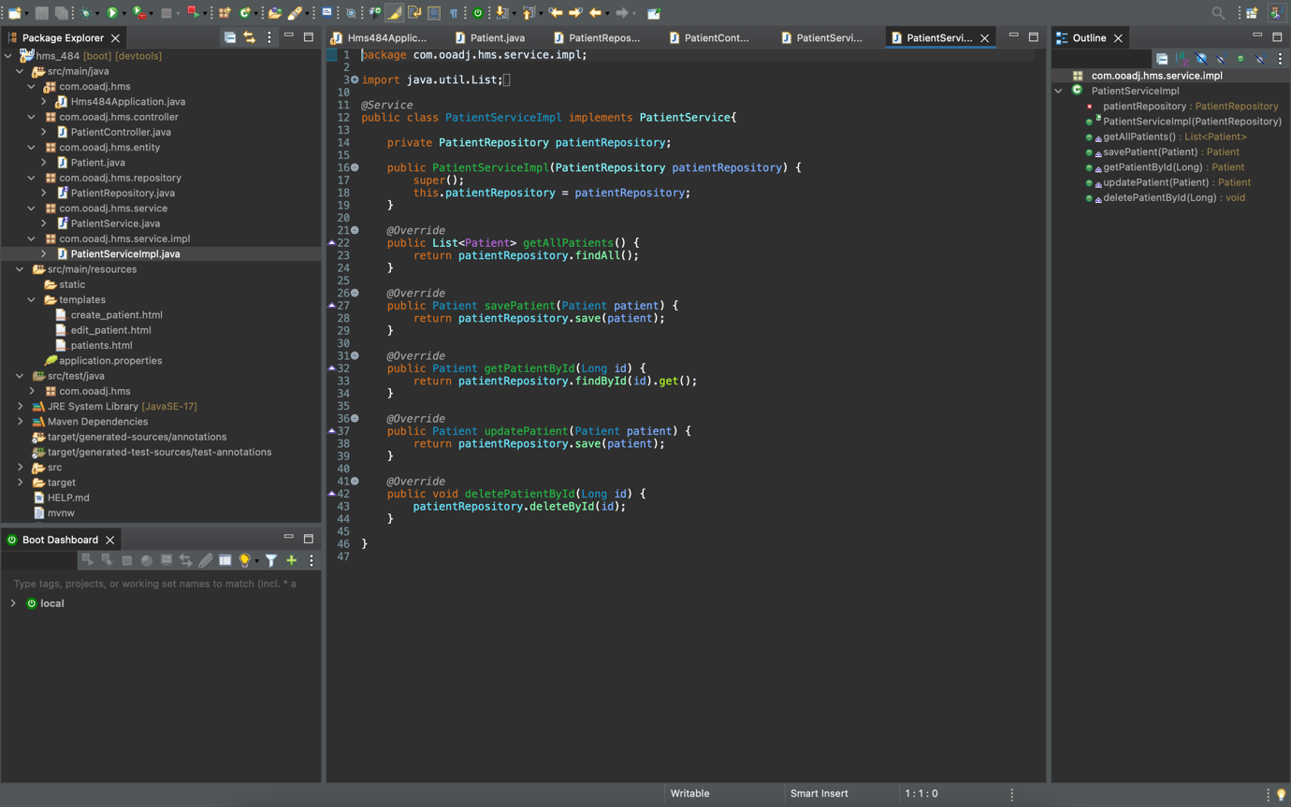

patients.html

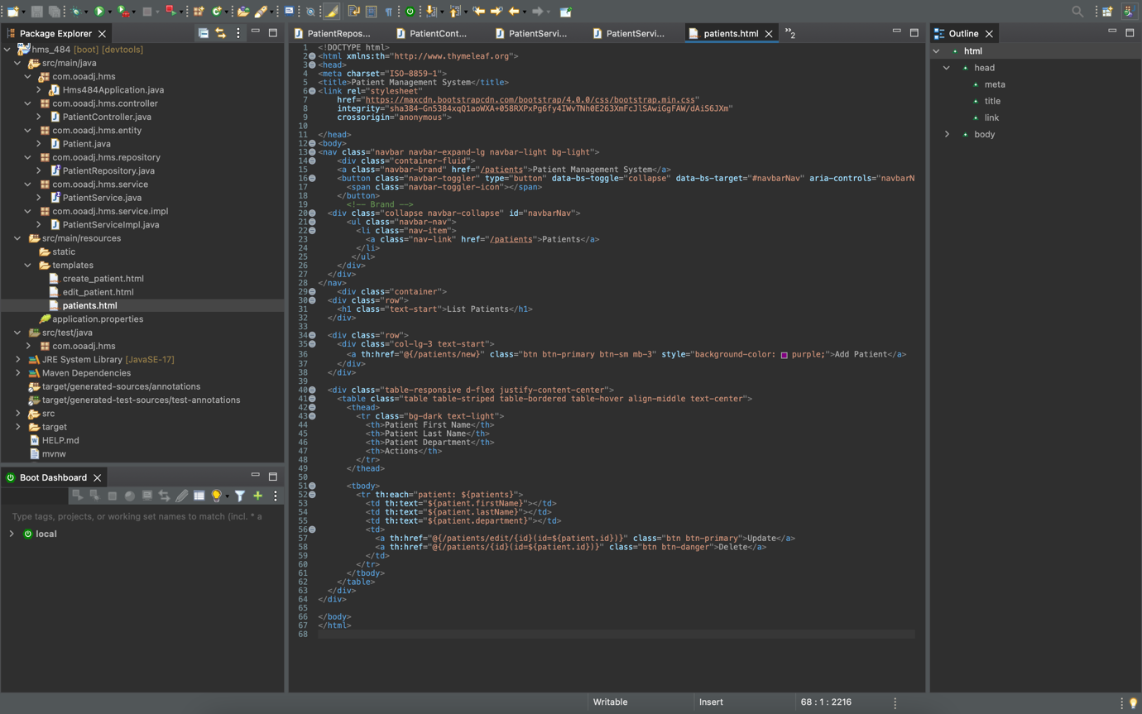

create_patient.html

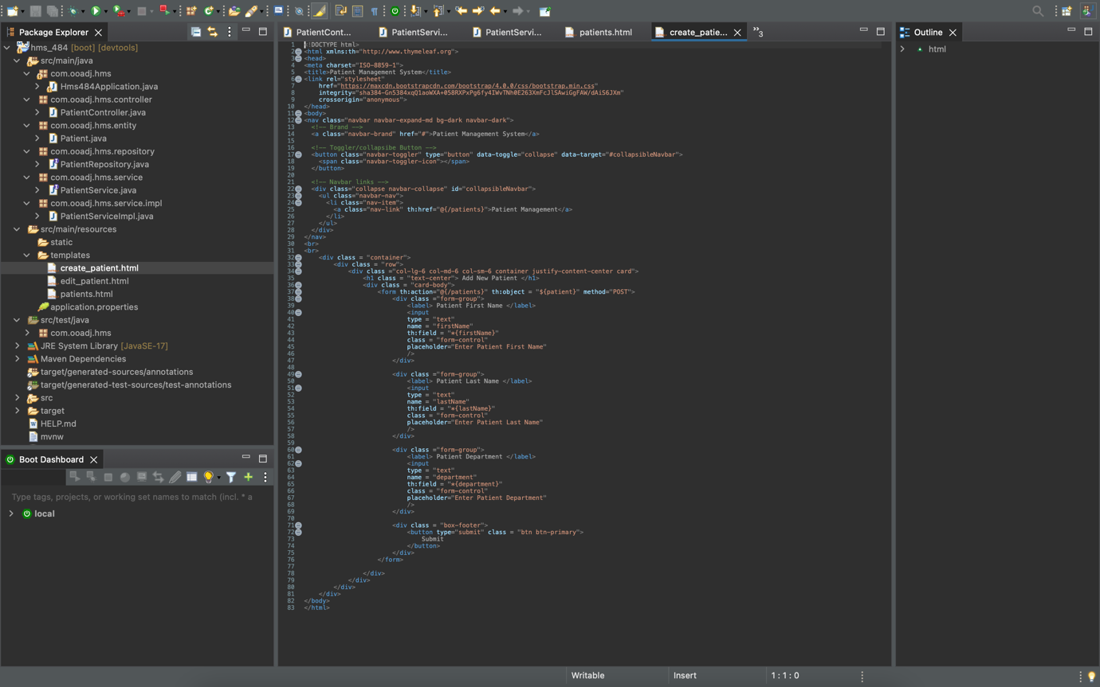

edit_patient.html

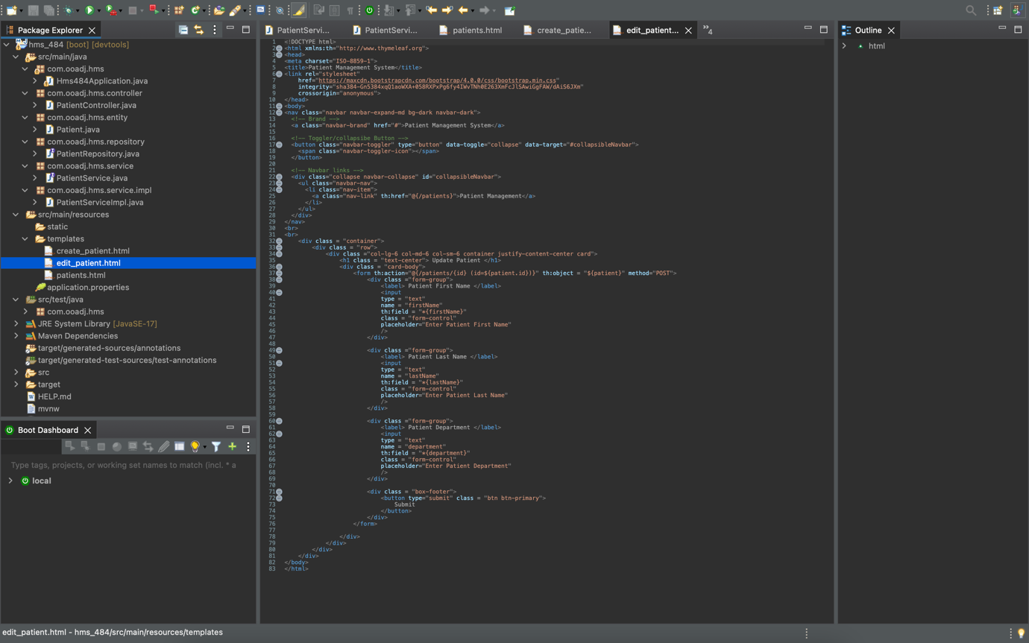

application.properties file

(It has the MySQL Database name mentioned as well as the username and password for MySQL server)

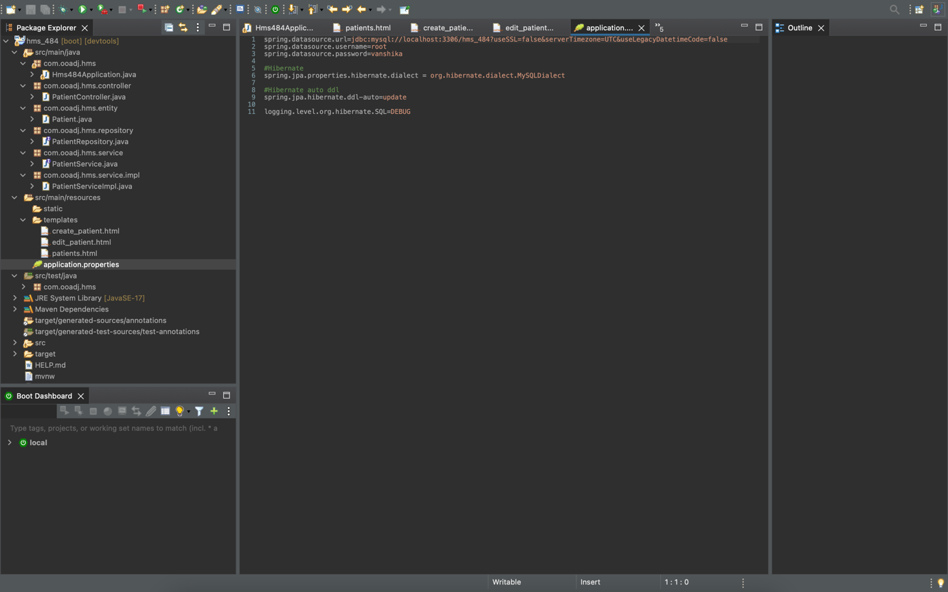

1. **Screenshot of console with application running**

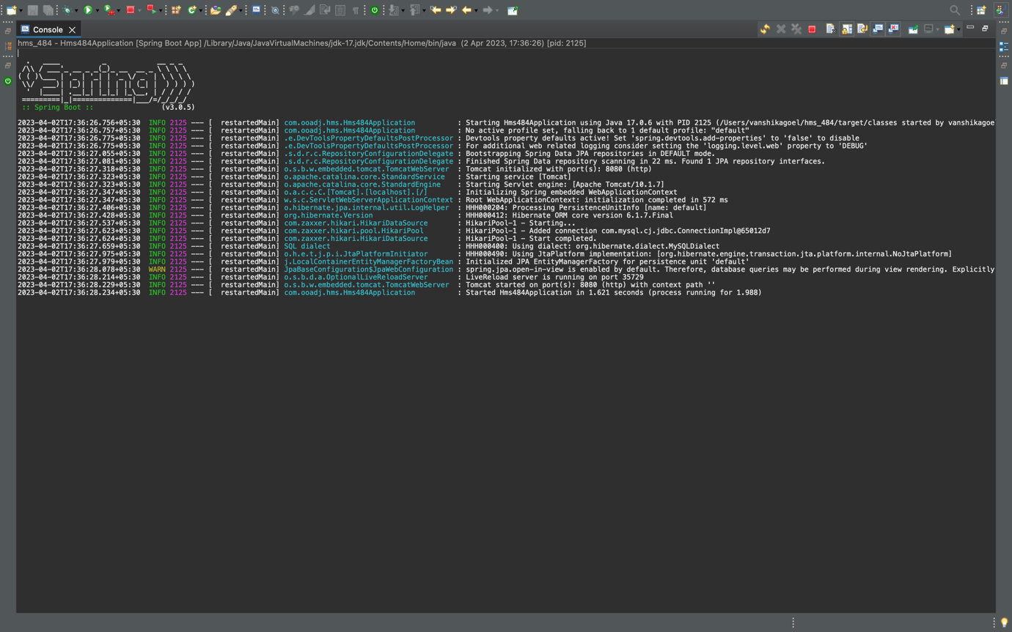

Console view of all CRUD operations being performed by the application on the MySQL server

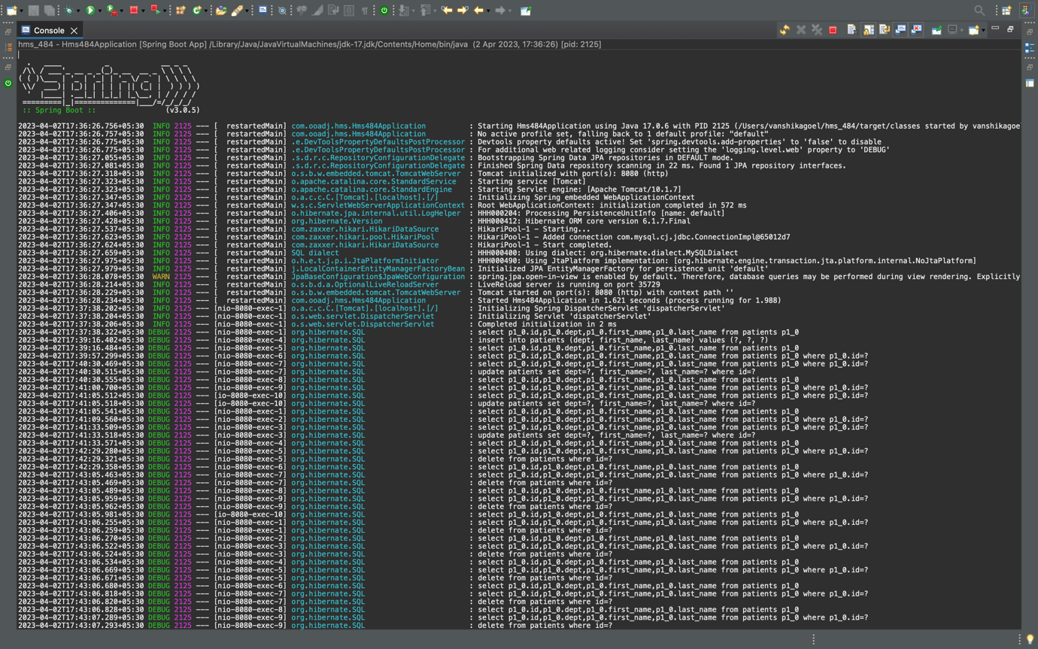

1. **Screenshot of UIs related to the two scenarios with values, outputs, errors (if any)**

Patient Management System Home Page

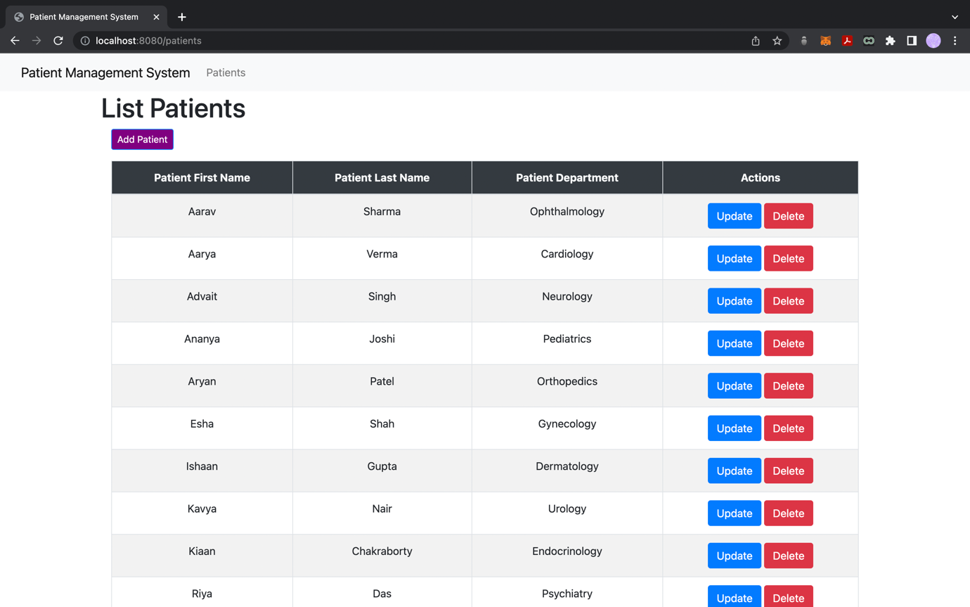

Add New Patient Page

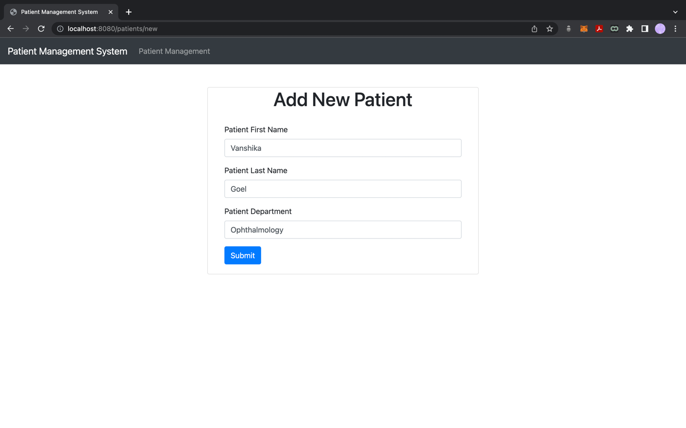

New Patient Details Added

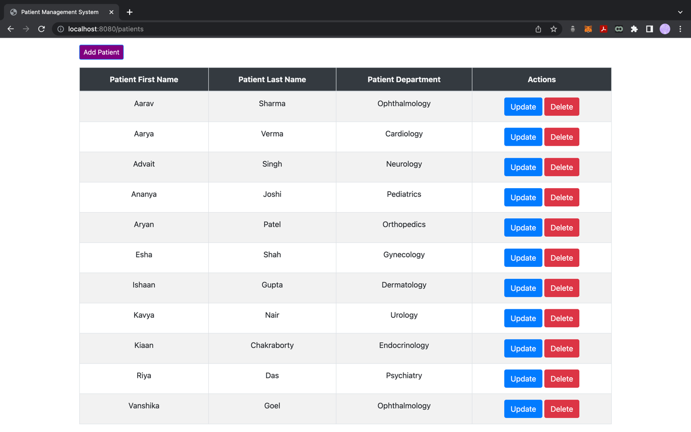

Update Patient Details

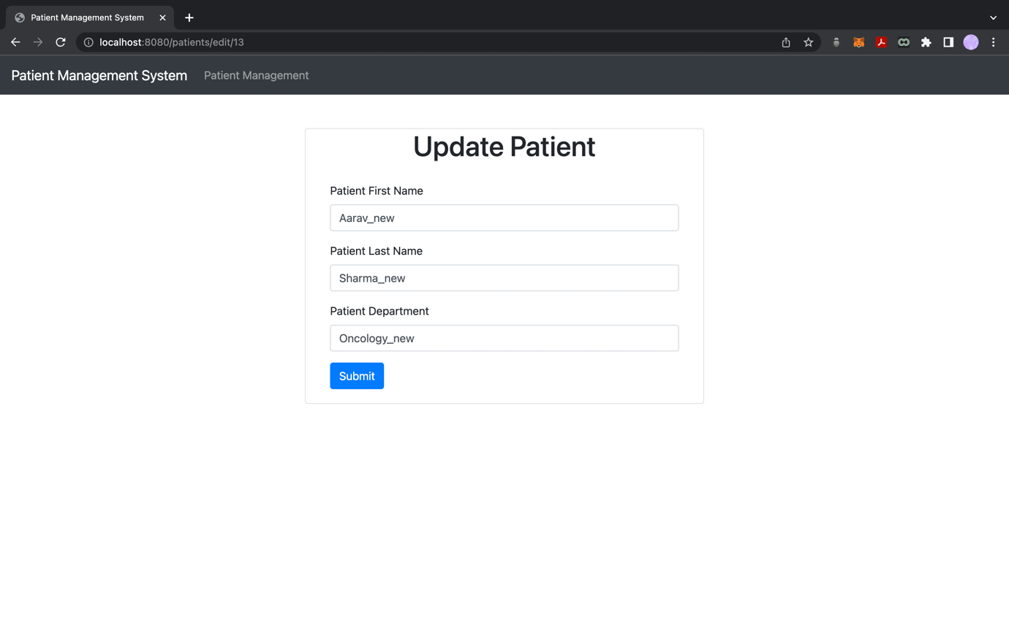

Patient Details Updated as shown above and below

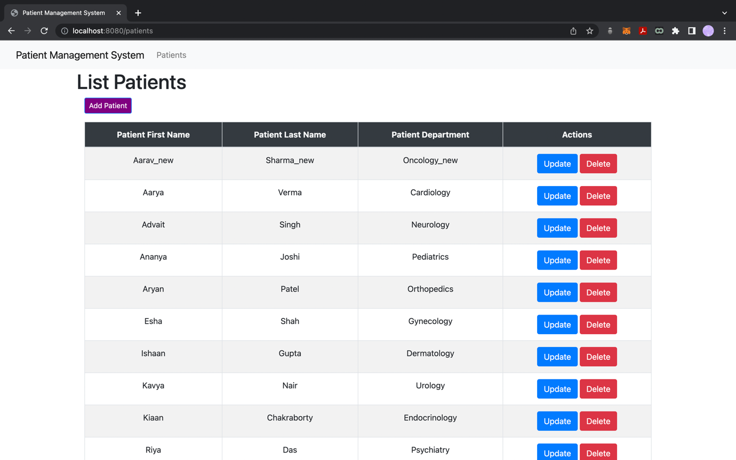

Patient Details Deleted

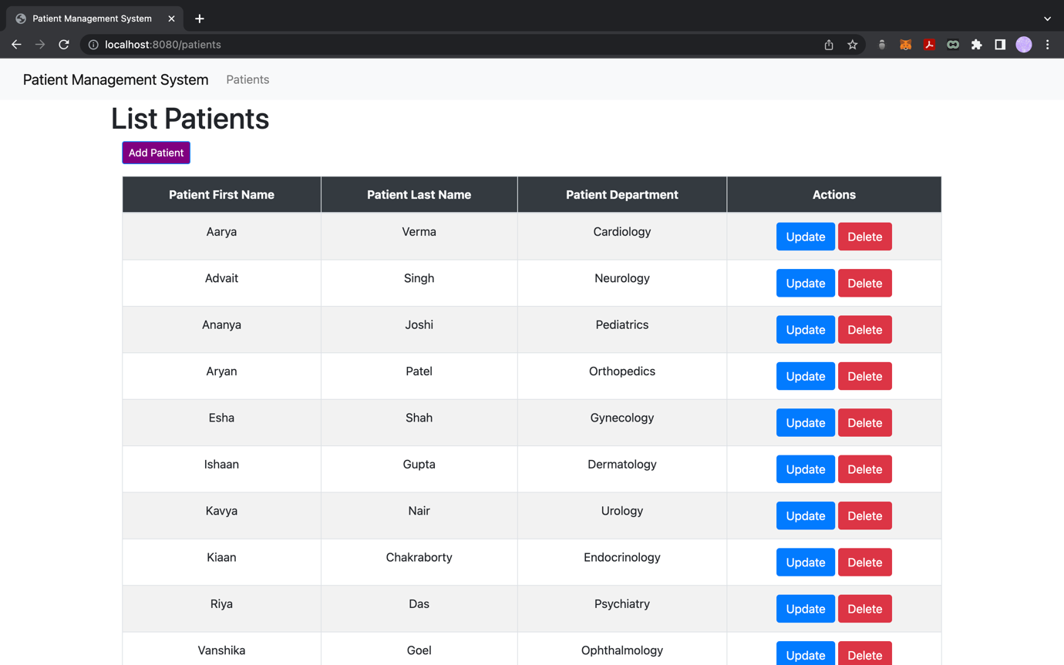

1. **Screenshot of database with data items**

MySQL Database Before Addition, Updating or Deletion of Data

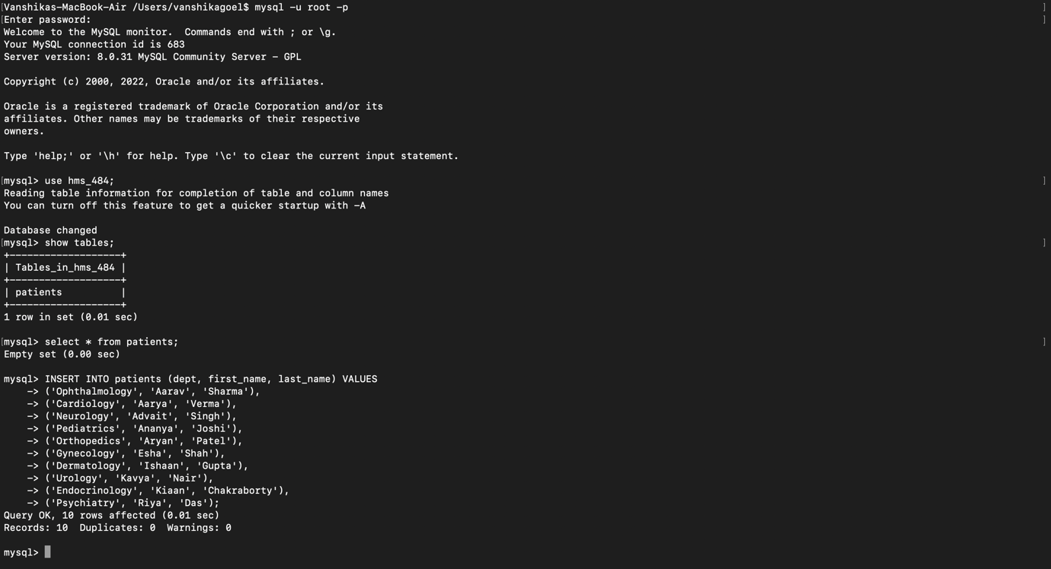

After Adding New Patient Details, as shown in the previous point.

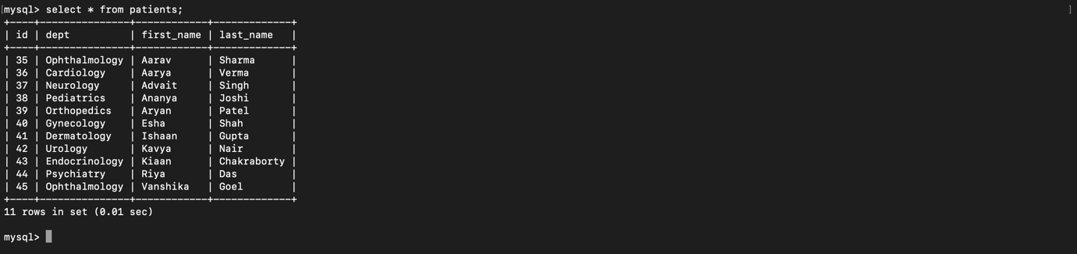

After Updating Patient Details, as shown in the previous point.

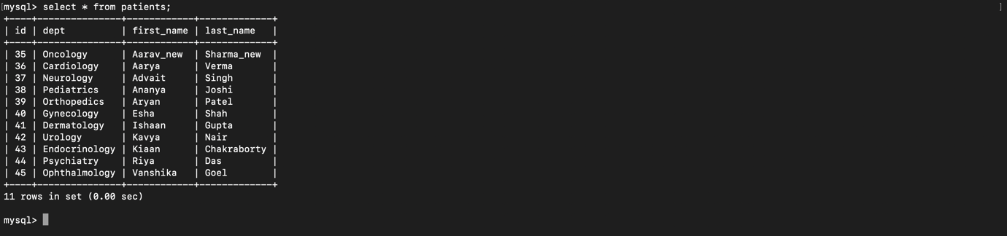

After Deleting Patient Details, , as shown in the previous point.

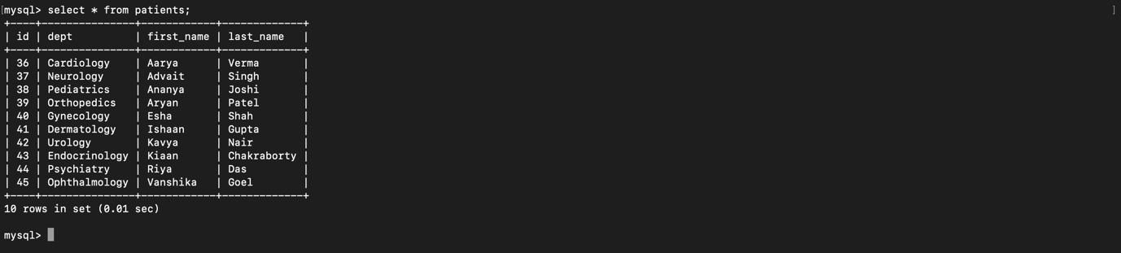

Complete view of all operations performed on MySQL Database

